

UNITEDWORLD INSTITUTE OF TECHNOLOGY (UIT)

**End-Semester Practical**

Submitted by

Patel Zalak Bipinkumar

20220701020

**Data Visualization**

**(21BSCS35C02)**

B. Sc. Computer Science -DS/AIML

V Semester, July -Nov 2024



November 2024

1. **Title:** Visualization of Walmart Customer Analysis
2. **Dataset Source:** <https://github.com/stanley-george-joseph/Customer-Analysis-Tableau>
3. **Dashboard:**

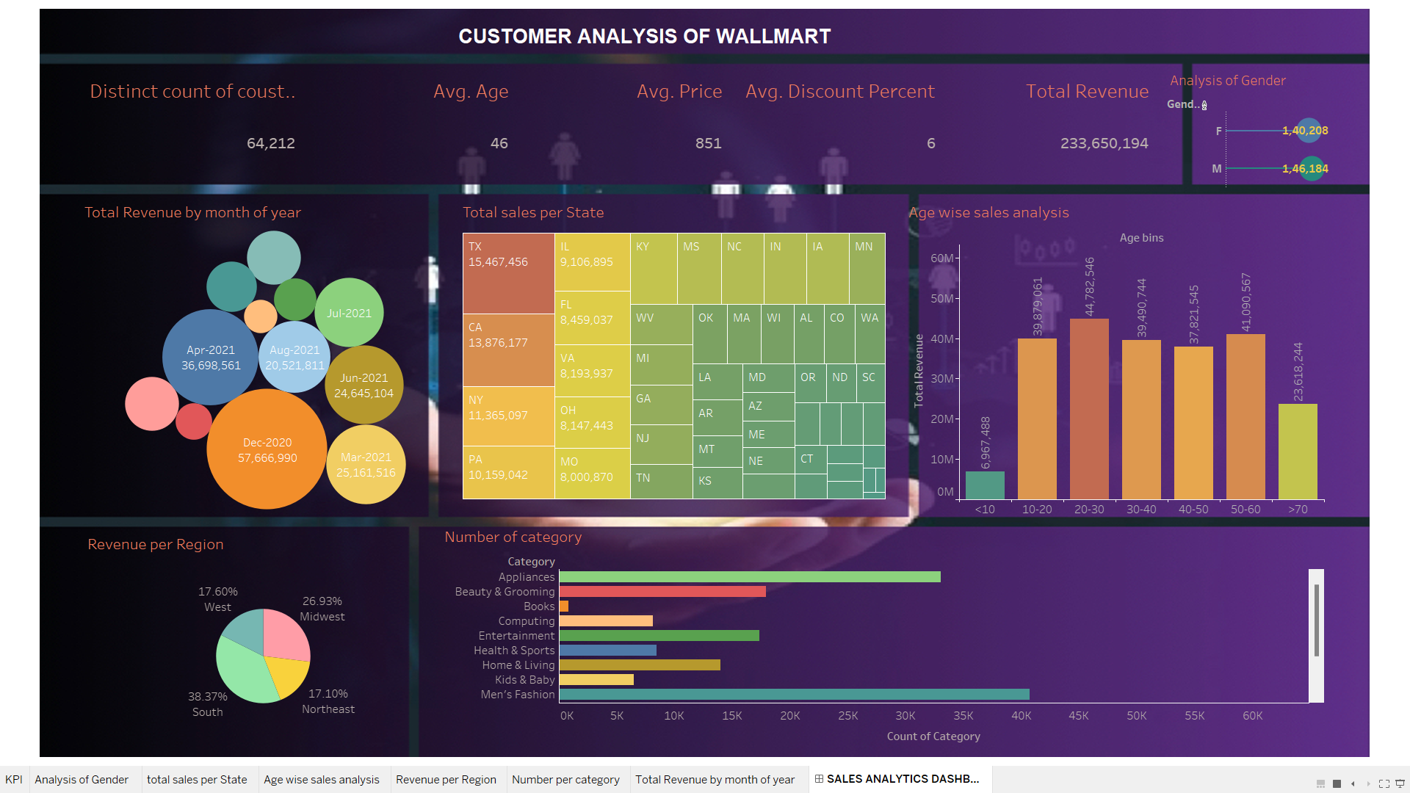

1. **Explanation:**

**Charts and Insights**

1. **Top KPIs**  
   The dashboard shows key metrics such as the distinct count of customers (64,212), average age (46), average price (851), average discount percentage (6) and total revenue (233,650,194). It also includes an analysis of revenue by gender, where female customers contribute 140,208 and male customers contribute 146,184.
2. **Total Revenue by Month of Year (Bubble Chart)**  
   A bubble chart represents revenue generated each month, with bubble size and colour indicating revenue levels. December 2020 shows the highest revenue (57,666,990), followed by significant contributions in months like April 2021 and July 2021.
3. **Total Sales per State (Treemap)**  
   A treemap visualizes revenue by state, with larger blocks representing states with higher sales. Texas leads with 16,467,456, followed by California and Florida.
4. **Age-wise Sales Analysis (Bar Chart)**  
   A bar chart breaks down revenue by age group. The 30-40 age group generates the highest revenue, followed by 40-50. The <10 and >70 age groups contribute the least.
5. **Revenue per Region (Pie Chart)**  
   A pie chart shows the revenue distribution across regions. The South accounts for 38.37 percent of revenue, the Midwest for 26.93 percent, the West for 17.60 percent, and the Northeast for 17.10 percent.
6. **Number of Categories (Bar Chart)**  
   A bar chart displays the number of sales by product category.

**Dashboard Design**

1. **Background Color**  
   The dashboard uses a dark purple background with white and yellow text, which enhances readability and creates a modern look.
2. **Filters**  
   A filter panel for gender is available, allowing users to view data specifically for male or female customers.
3. **Interactive Elements**  
   The dashboard includes interactive features like clicking on a region or state to filter the data accordingly.
4. **Layout**  
   The layout groups metrics logically. KPIs are at the top, followed by visualizations for monthly revenue, states, and demographics. Regional and category-level insights are displayed through a pie chart and bar chart.

This project provides a comprehensive analysis of Walmart's sales data, highlighting key performance indicators and uncovering trends in customer demographics, regional sales, and product performance. The analysis reveals that Walmart generated a significant revenue of *233.65 million, with the **South region* contributing the largest share (*38.37%), followed by the **Midwest* and *West* regions. Middle-aged customers (aged *30-50) emerged as the most profitable segment, while younger and older demographics contributed minimally. Seasonal trends were evident, with **December 2020* recording the highest monthly revenue, likely due to holiday shopping. *Texas* led state-wise sales, and categories like *Beauty & Grooming* and *Health & Sports* dominated in product performance. Gender analysis showed a near-equal contribution from male and female customers. Overall, the project offers actionable insights into customer preferences, regional opportunities, and seasonal patterns, aiding in strategic decision-making to enhance sales and target growth areas effectively.